Bootstrap 5 Cards

## **Cards**

A card in Bootstrap 5 is a bordered box with some padding around its content. It includes options for headers, footers, content, colors, etc.



## **Basic Card**

A basic card is created with the .card class, and content inside the card has a .card-body class:

### **Example**

<div class="card">  
  <div class="card-body">Basic card</div>  
</div>

Output



## **Header and Footer**

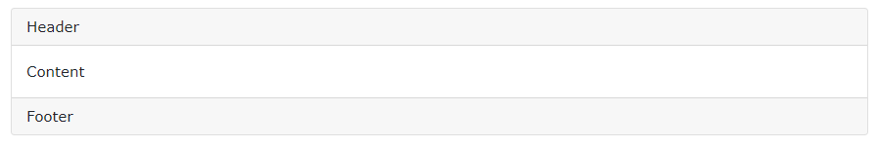

The .card-header class adds a heading to the card and the .card-footer class adds a footer to the card:

### **Example**

<div class="card">  
  <div class="card-header">Header</div>  
  <div class="card-body">Content</div>  
  <div class="card-footer">Footer</div>  
</div>

## **Card Images**

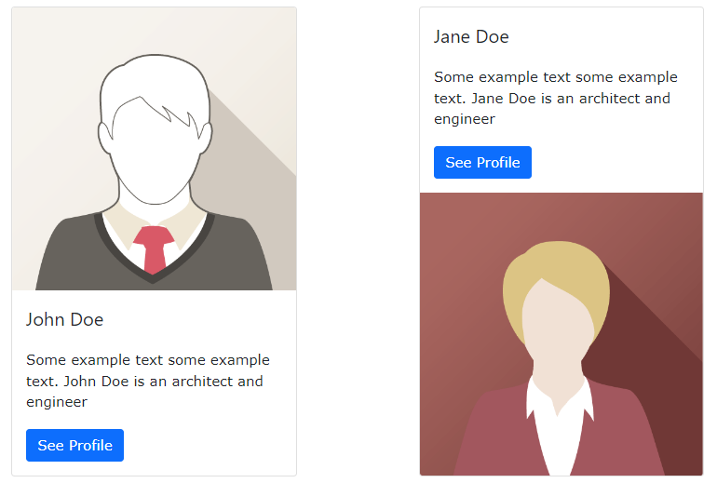

Add .card-img-top or .card-img-bottom to an <img> to place the image at the top or at the bottom inside the card. Note that we have added the image outside of the .card-body to span the entire width:

### **Example**

<div class="card" style="width:400px">  
  <img class="card-img-top" src="img_avatar1.png" alt="Card image">  
  <div class="card-body">  
    <h4 class="card-title">John Doe</h4>  
    <p class="card-text">Some example text.</p>  
    <a href="#" class="btn btn-primary">See Profile</a>  
  </div>  
</div>

For more information [clickhere](https://www.w3schools.com/bootstrap5/bootstrap_cards.php)

References

https://www.w3schools.com/bootstrap5/bootstrap_cards.php